What is a Bedded Pack Barn?
A bedded pack barn is an alternative for livestock producers in South Dakota. Producers are increasingly utilizing this type of animal housing for beef cattle feeding and dairy operations in this region. There are different variations of bedded pack barns, which include different types of buildings, different types of bedding and different types of bedded pack management.

The two most common types of bedded pack buildings are hoop structures and mono-slope structures.

Hoop structures are generally constructed with wood or concrete sidewalls, tubular steel truss system, and a woven polyethylene fabric cover.

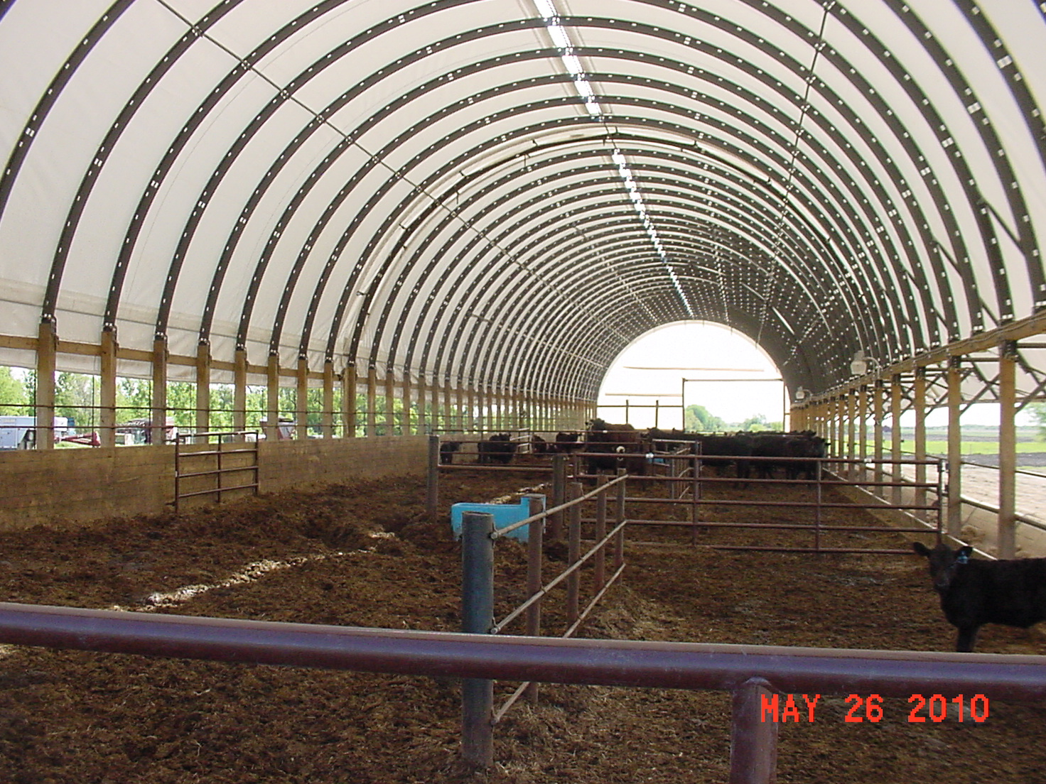

Mono-slope structures have been typically constructed with concrete walls, steel frame, and steel roof.
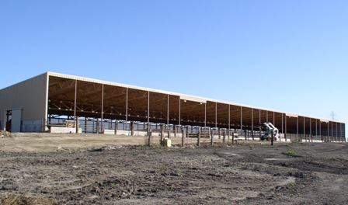

From a manure management standpoint, bedded pack barns provide two distinct differences from traditional open lots. The first is that the bedding in the barns absorbs the water in the manure and the second is that the roof keeps precipitation out of the cattle feeding area. This eliminates runoff from the feeding operation and the need for runoff collection, storage, and treatment measures. For facilities with geotechnical conditions not conducive to constructing runoff storage ponds, this can make a barn the preferred option to feed cattle at the location.

Advantages of a Bedded Pack Barn
Versus a Traditional Open Lot

- The animal density (animals per square foot of space) is higher, so the overall space required for the cattle feeding area is smaller.
- Collection, storage and application of open lot runoff are eliminated.
- Manure storage and application is more predictable and consistent than open lot runoff. Open lot runoff is dependent on variable precipitation, not on manure and bedding accumulation.
- Lower chance of a catastrophic manure spill since manure is stored and handled as a solid.
- In locations with high groundwater where a holding pond is not feasible, a barn may provide an option to feed cattle.
- There is a somewhat controlled environment inside of the barn for the animals and the producer.
Disadvantages of a Bedded Pack Barn
Versus a Traditional Open Lot

- Higher initial investment.
- Adequate bedding and an area to store the bedding are necessary.
- Ventilation of the facility must be managed.
- More regular maintenance to add bedding and remove manure and bedded pack from the barn.

